**E-Bookstore Management System**

**Prepared by:**

**Project Team Lead** <Nashra Ghaffar, Roll# CT- 032>

**System Analyst** <M. Abdul Rafay, Roll# CT 012>

**Members:**

<Mehak Hussain, Roll# CT- 030>

<Mahshid Fatima, Roll# CT- 023>

**OVERVIEW OF THE SYSTEM**

This is a bookstore management system where people can order the books which they want and even they do not need to bother about the location and do not worry about picking it up from the store. This system will help you to get the book from the store to your home with just a single click. We can also make the payment after delivery of the book which will make us feel safe regarding our money. We also have weekly magazine in which you can publish your mini articles and stories etc.

**FUNCTIONAL AND NON-FUNCTIONAL FEATURES OF THE SYSTEM:**

* Admin Panel (There is a portal for admin in which admin can add and remove books, admin also has access to the user details).
* Register Yourself (A customer needs to first register himself to buy any book).
* Login yourself (A registered customer needs to login).
* Cart (A customer can add & remove books in cart ).
* Purchase Books (After registration, a user can buy books and novels of his/her own choice with such a reasonable price)
* Payment Module (There are three payment methods in our system, that are COD, Paypal and Credit Card)
* Publish articles (The old users also gets the facility to publish his/her stories, articles etc on our webpage.)
* Help Centre (There is a portion which contains all the details of our system from where user can seek help and understand what actually this system is , also there is a 24/7 service available for the users.)
* Feedback (Behind the success of every business, there are the reviews of customers whether they are good or bad. So there is a feature of feedback where user can share his/her experience and suggest us to make the betterment.)

**GANTT CHART**

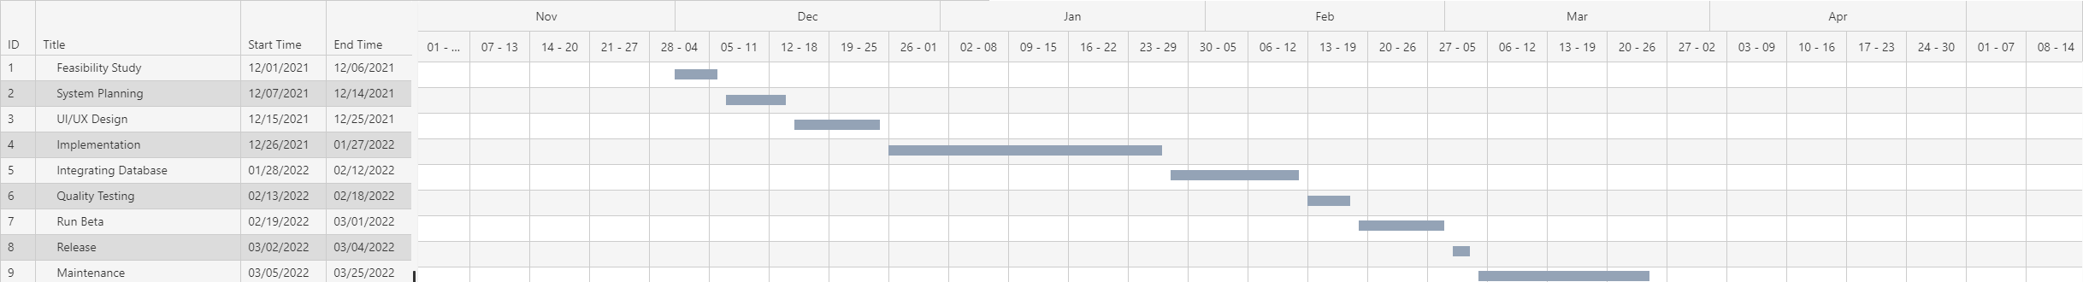

**WORK BREAKDOWN STRUCTURE:**

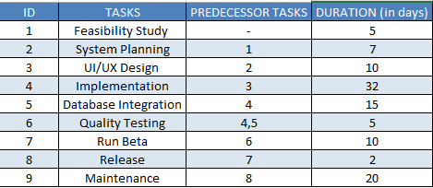

**PERT CHART(CPM):**

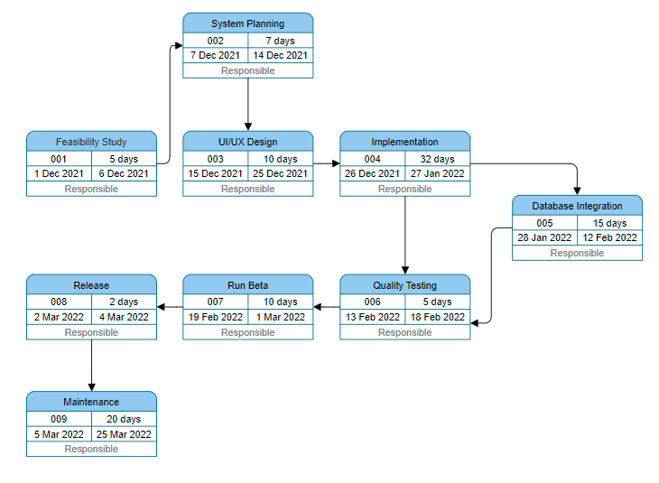

Critical Path : (1 , 2 , 3 , 4 ,6 , 7 , 8 , 9 )

**APPROACH adopted for developing this assignment:**

**Roles and Responsibilities:**

**Nashra Ghaffar:** The idea of the system, features , and gantt chart .

**M. Abdul Rafay:** Work Breakdown Structure, Pert Chart and CPM.

**Tools:**

**Gantt Chart:** Visual Paradigm

**WBS:** MS Excel

**Pert Chart:** Visual Paradigm

**Limitation:**

In the pert chart, the days were written automatically , as I wrote the date from 1st to 6th so the no of days automatically turned 5.